CATALOGUE 2025/26

UP DONA, D.O.O.



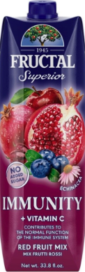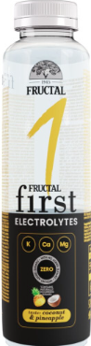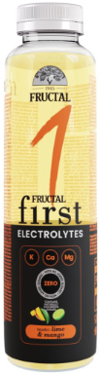

 | 2 | GENERAL INFORMATION
  ISSUER:  UP Dona, d. o. o.Production, services and trade  Secondary School of Economics, Services and Civil Engineering, SC Kranj, Cesta Staneta Žagarja 33, 4000 Kranj  Tel: 00386 059 093 900 Fax: 00386 059 093 901  E-mail: updona7@gmail.com  https://donaeng.splet.arnes.si  RELEASE DATE:  september 2025 | AUTHORS OF THE CATALOGUE:  ● MELSIN KOLENOVIC, company director (Fructal beverages 7)  ● ZAN BEGOVIC, Marketing Director (Fructal beverages 8)  ● MIHA KOS, Purchasing and Sales Officer 1 (Fructal beverages 9)  ● ERAZEM FICKO, Purchasing and Sales Officer 2 (Fructal beverages 10)  ● MAJA MALETIC, Purchasing and Sales Officer 3 (Fructal beverages 11)  ● TIJANA JEGDIC, Purchasing and Sales Officer 4 (Fructal beverages 12) | TERMS OF SALE:  The offer is valid until stocks last.  The images are symbolic.  SPONSORED BY THE LEARNING COMPANY:  
 | 3 | INDEX
CATALOGUE INDEX:

GENERAL INFORMATION 1
INDEX 3
FRUCTAL DRINKS 7 4
FRUCTAL DRINKS 11 5
FRUCTAL DRINKS 12 6
FRUCTAL DRINKS 13 7
FRUCTAL DRINKS 15 8
FRUCTAL DRINKS 14 9

 | 4 | FRUCTAL DRINKS 7
 | NECTAR IMMUNITY, POMEGRANATE AND BLUEBERRY, FRUCTAL, 1L  Ingredients: fruit juices from concentrated juices (grape juice 40%, apple juice 23%, pomegranate juice 10%, blueberry juice 7%) ...  €1.98  Article No. 78211 |  | WATER FIRST, PINEAPPLE - KOSOS, PET, FRUCTAL, 0.5 L  Ingredients: water, pineapple juice from concentrated juice (1.5%), coconut juice ...  €0.97  Article No. 78212 | WATER FIRST, LIME - MANGO, PET, FRUCTAL, 0.5 L  Ingredients: water, apple juice from concentrated juice (1.5%), mango juice from concentrated juice (0.5%), lime juice from concentrated juice (0.5%) ...  €0.97  Article No. 78213
 | CARBONATED DRINK, STRAWBERRY, ROBBY, 0.75 L  Ingredients: mineral water, white grape concentrate, sugar, carbon dioxide, cyron ki saliva, vitamin C ...  €2.77  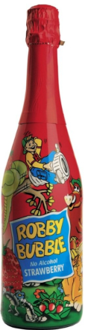  Article No. 78214 |  | BEETROOT JUICE, BIO ZONE, 0.5 L  Ingredients: ORGANIC BEETROOT JUICE FROM CONCENTRATED BEETROOT JUICE*, ACID (CITRIC ACID)*from controlled organic production ...  €1.01  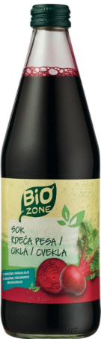  Article No. 78215 | SYRUP, FOREST FRUITS, FRUCTAL, 1 L  Ingredients: glucose-fructose syrup, sugar, water, apple (5%), strawberry (2%), blueberry (2%), raspberry (2%) juice from concentrated juices ...  €4.62  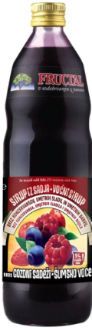  Article No. 78216

 | 5 | FRUCTAL DRINKS 11
 | SYRUP, ICED TEA, DANA, 1 L  Ingredients: peaches, water, sugar ...  €3.85  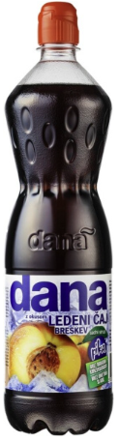  Article No. 118211 |  | SYRUP, LEMON BALM AND MINT, BROZOVIČ, 0.7 L  Ingredients: water, sugar, citric acid, lemon, lemon balm, mint  €6.48  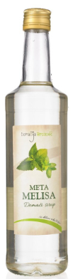  Article No. 1182121 | SYRUP, ELDERBERRY, YO, 0.7 L  Ingredients: Pasteurized without added preservatives and dyes. Ingredients: sugar, glucose-fructose syrup, water, elderflower extract, acid: citric acid, juice from concentrated lemon juice, aroma, caramelized sugar, stabilizers: gum arabicum and glycerol esters of wood resins.  €3.42  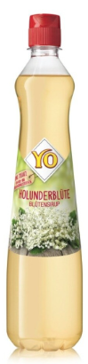  Article No. 118213
 | SYRUP, ELDERBERRY AND LEMON, DANA, 1 L  Ingredients: sugar, water, acid (citric acid), apple fruit juice (2%), lemon from concentrated juice (min. 1%), flavouring, elderberry extract, antioxidant (ascorbic acid), stabiliser (gum arabica) and colour (beta carotene).  €3.77  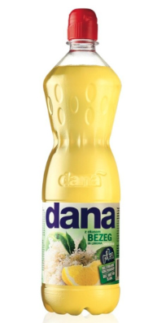  Article No. 118214 |  | SYRUP, BLUEBERRY, DANA, 1 L  Ingredients: sugar, water, apple fruit juice from concentrated apple juice (min.8%), blueberry fruit juice from concentrated blueberry juice (min.1%),natural colour (anthocyanins) acid (citric acid) and flavourings  €3.77  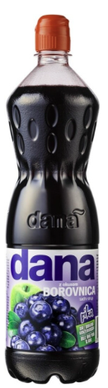  Article No. 118215 | SYRUP, MERINGUE, FRUPI, 1 L  Ingredients: sugar, water, acid (citric acid), lemon juice from concentrated juice (2%), natural flavouring, stabiliser (gumi arabicum), elderflower extract (0.02%), antioxidant (ascorbic acid) and colour (beta carotene). Protect from direct sunlight.  €3.85  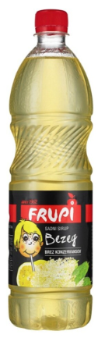  Article No. 118216

 | 6 | FRUCTAL DRINKS 12
 | SYRUP, ICED TEA, DANA, 1 L  Ingredients: peaches, water, sugar ...  €3.85  Article No. 128211 |  | SYRUP, LEMON BALM AND MINT, BROZOVIC, 0.7 L  Ingredients: water, sugar, citric acid, lemon, lemon balm, mint  €6.48  Article No. 1282121 | SYRUP, ELDERBERRY, YO, 0.7 L  Ingredients: Pasteurized without added preservatives and dyes. Ingredients: sugar, glucose-fructose syrup, water, elderflower extract, acid: citric acid, juice from concentrated lemon juice, aroma, caramelized sugar, stabilizers: gum arabicum and glycerol esters of wood resins.  €3.42  Article No. 128213
 | SYRUP, ELDERBERRY AND LEMON, DANA, 1 L  Ingredients: sugar, water, acid (citric acid), apple fruit juice (2%), lemon from concentrated juice (min. 1%), flavouring, elderberry extract, antioxidant (ascorbic acid), stabiliser (gum arabica) and colour (beta carotene).  €3.77  Article No. 128214 |  | SYRUP, BLUEBERRY, DANA, 1 L  Ingredients: sugar, water, apple fruit juice from concentrated apple juice (min.8%), blueberry fruit juice from concentrated blueberry juice (min.1%),natural colour (anthocyanins) acid (citric acid) and flavourings  €3.77  Article No. 128215 | SYRUP, MERINGUE, FRUPI, 1 L  Ingredients: sugar, water, acid (citric acid), lemon juice from concentrated juice (2%), natural flavouring, stabiliser (gumi arabicum), elderflower extract (0.02%), antioxidant (ascorbic acid) and colour (beta carotene). Protect from direct sunlight.  €3.85  Article No. 128216

 | 7 | DRINKS FRUCTAL 13
 | NON-CARBONATED NATURAL MINERAL WATER, DANA, 0.33 L  Water 0.33 L  €0.37  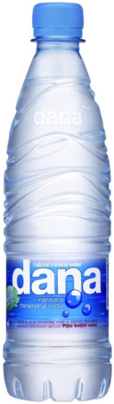  Article No. 138212 |  | NON-CARBONATED NATURAL MINERAL WATER, DANA, 1.5 L  Water 1.5 L  €0.55  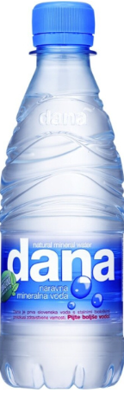  Article No. 138213 | NON-CARBONATED NATURAL MINERAL WATER, DANA, 0.5 L  Water 0.5 L  €0.41  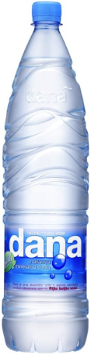  Article No. 138211
 | NON-CARBONATED NATURAL MINERAL WATER, DANA,1 L  Water 1 L  €0.47  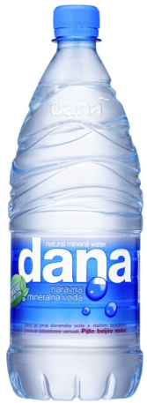  Article No. 138214 |  | JUICE, 100% APPLE, DANA, 1 L  Apple juice from apple juice concentrated  €1.77  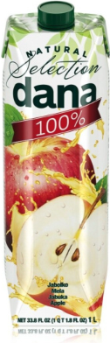  Article No. 138215 | DRINK, MANGO, DANA, 1 L  Ingredients: water, mango puree from concentrated puree (min. 10.5%), sugar, peach puree (min. 5%), orange juice from concentrated juice (min. 5%), acid (citric acid), antioxidant (ascorbic acid) and flavors  €2.52  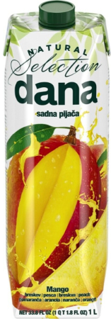  Article No. 138216

 | 8 | FRUCTAL DRINKS 15
 | STILL WATER, IMMUNO, DANA, 0.75 L  Water, sugar, acid (citric acid), natural flavourings, vitamins C and B7, zinc (zinc gluconate), natural American straw extract (0.05 g/l) and colouring agent (E160e).  €1.16  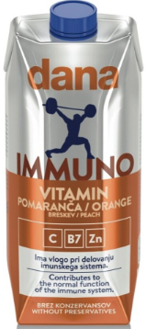  Article No. 158211 |  | STILL WATER, IMMUNO, DANA, 0.75 L  Ingredients: water, sugar, acid (citric acid), guarana extract (0.7 g/l) - natural source of caffeine, natural hop extract (0.7 g/l), natural flavouring, colour (black root concentrate, safflower and lemon juice), vitamins (niacin, pantothenic acid, B6, B12).  €1.14  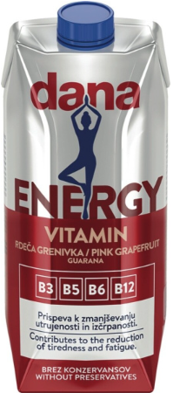  Article No. 158212 | STILL WATER, LEMON, JANA, 0.5 L  water, sugar, fructose syrup, concentrated lemon juice (1.5%), natural flavourings, acid: citric acid, natural lemon flavouring, natural citrus flavouring, acidity regulator E331, stabilisers: E414 and E445, zinc gluconate, sweetener: steviol glycoside, vitamins: C, B6 and B12  €0.89  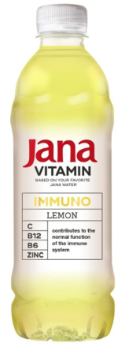  Article No. 158213
 | DRINK, APPLE, DANA, 0.2 L  Water, apple fruit juice from concentrated juice (10%), sugar, acid (citric acid), calcium lactate, colour (kara-mel) and flavouring.  €0.44  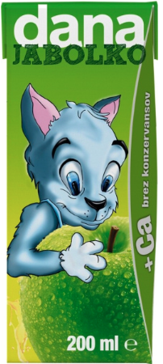  Article No. 158214 |  | FLAVORED WATER, ELDERBERRY, DANA, 1 L  Water, sugar, acidity regulator (citric acid), lemon juice (1.2%) and apple juice (1%) from concentrated juices, kumquat aroma, natural elderflower extract (0.03%) and preservatives (K-sorbate and Na-benzoate).  €0.72  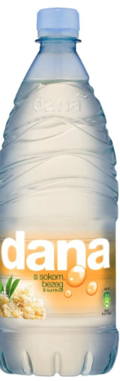  Article No. 158215 | FLAVOURED WATER, WHITE PLUM, DANA, 1 L  Water, sugar, 2% plum juice from concentrated juice, acidity regulators (citric acid and Na-citrate), preservatives (K-sorbate and Na-benzoate), flavoring and green tea extract (0.05%).  €1.92  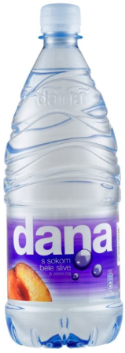  Article No. 158216

 | 9 | FRUCTAL DRINKS 14
 | STILL WATER, DETOX, DAYS, 0.75 L  Orange juice from orange concentrated juice  €1.25  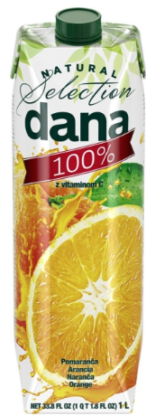  Article No. 148212 |  | SUGAR-FREE STILL WATER, RASPBERRY, ZALA, 1.5 L  Water, sugar, acid (citric acid), natural nettle extract (0.5 g/l), flavourings, vitamins C, E and B3 and natural colour (safflower and lemon juice). The product is recommended as part of a varied and balanced diet and a healthy lifestyle. Pasteurized.  €0.80  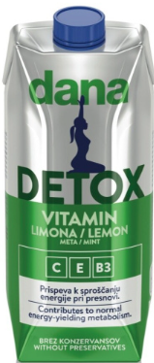  Article No. 148213 | STRAWBERRY AND APPLE DRINK  Water, concentrated juice of apples and lemons, concentrated raspberry juice (0.1%), natural flavouring.  €2.06  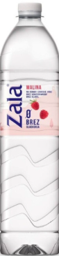  Article No. 148214
 | DRINK, APPLE, DANA, 1.5 L  Ingredients: apples, berries, water, sugar.  €1.80  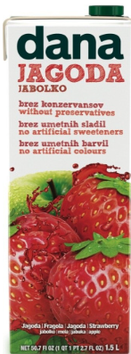  Article No. 148215 |  | STILL WATER, ACTIVE FIT  Water, apple juice from concentrated juice, sugar, acid (citric acid), natural color (caramel) and aroma.  €2.56  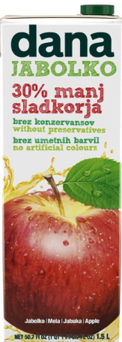  Article No. 148216 | JUICE, 100% ORANGE, DANA, 1 L  water, sugar, acid (citric acid), natural chamomile extract (1 g/l), natural flavouring, vitamins C, B6, B3, B5 and B7, colour (E150d) and L-carnitine (0.05 g/l). The product is recommended as part of a varied and balanced diet and a healthy lifestyle. Pasteurized.  €2.13  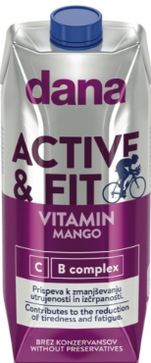  Article No. 1482111

