CATALOGUE 2025/26

UP ZOJO D. O. O.



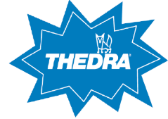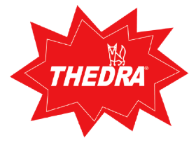

 | 2 | GENERAL INFORMATION
  ISSUER:  UP Zojo, d. o. o.  Production, services and trade  Secondary School of Economics, Services and Civil Engineering, SC Kranj, Cesta Staneta Žagarja 33, 4000 Kranj  Tel: 00386 059 093 900  Fax: 00386 059 093 901  E-mail: upzojo7@gmail.com  https://zojoeng.splet.arnes.si  RELEASE DATE:  september 2025 | AUTHORS OF THE CATALOGUE:  ● ANASTASIA KRSTEVA, Director of the Company  (cleaners 7)  ● NIKOLINA NINIĆ, Marketing Director (cleaners 12)  ● URBAN PIRC, Purchasing and Sales Officer 11  (cleaners)  ● ROK PLEVNIK, Purchasing and Sales Officer 2  (cleaners 9)  ● JAKA TRILLER, Purchasing and Sales Officer 3  (cleaners 8)  ● JELENA VUKELIĆ, Purchasing and Sales Officer 4  (cleaners 13) | TERMS OF SALE:  The offer is valid until stocks last.  The images are symbolic.  SPONSORED BY THE LEARNING COMPANY:  
 | 3 | INDEX
CATALOGUE INDEX:

GENERAL INFORMATION 2
INDEX 3
CLEANERS 7 4
CLEANERS 12 6
CLEANERS 11 8
CLEANERS 9 10
CLEANERS 8 12
CLEANERS 13 14

 | 4 | CLEANERS 7
 | THEDRA AKTIVREINIGER – DEGREASER 10 L  Features: Dissolves strong dirt, removes nicotine and soot. Weakly foaming, good emulsifying power, fast action, wide application area.  €36.63  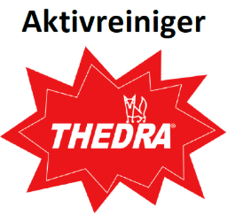  Article No. 71811 |  | THEDRA AKTIVREINIGER R6F – FOOD INDUSTRY DEGREASER 1L  Features: Aktivreiniger R6F is a highly effective cleaning concentrate for the removal of oily, greasy and pigment dirt. It is designed specifically for food processing plants. Tiles.  €3.85  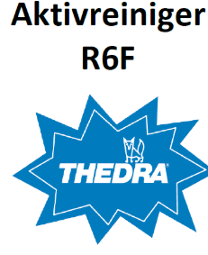  Article No. 71812 | THEDRA AKTIVREINIGER R6F – FOOD INDUSTRY DEGREASER 10L  Features: Aktivreiniger R6F is a highly effective cleaning concentrate for the removal of oily, greasy and pigment dirt. It is designed specifically for food processing plants. Weakly foaming surfactants allow for both machine and manual use. Tiles.  €33.94  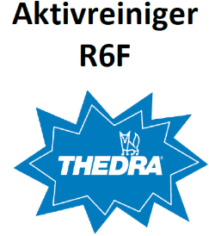  Article No. 71813
 | THEDRA TAPIMEX – EXTRACTION CLEANER FOR UPHOLSTERED FURNITURE 10 L  Features: Extracted carpet cleaner for cleaning upholstered furniture and carpets. It dissolves dirt and grease without any problems. It inhibits the reception of new dirt. The use of concentrate is very convenient for removing stains. Ideal for synthetics and wool carpets.  €49.31  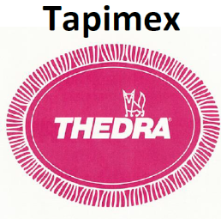  Article No. 71814 |  | THEDRA TEPPICH-SHAMPOO – SHAMPOO FOR UPHOLSTERED FURNITURE 1 L  Characteristics: THEDRA Tapifoam is an effective concentrate for basic cleaning and intermediate cleaning of carpets of all types and fibrous floor coverings according to the shampooing method. No optical brighteners. After drying, it forms dusty residues, which, together with the discarded dirt, are sucked up.  €3.85  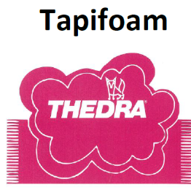  Article No. 71815 | HEDRA TEPPICH-SCHAMPOO – SHAMPOO FOR UPHOLSTERED FURNITURE 10 L  Characteristics: THEDRA Tapifoam is an effective concentrate for basic cleaning and intermediate cleaning of carpets of all types and fibrous floor coverings according to the shampooing method. No optical brighteners. After drying, it forms dusty residues, which, together with the discarded dirt, are sucked up.  €37.33  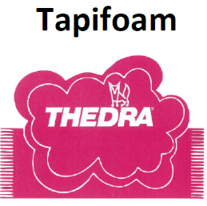  Article No. 71816

 | 5 | CLEANERS 12
 | FALA POOL-DES – HYGIENIC POOL CLEANER 10 L  For daily cleaning, dilute with water in a ratio of 1:32. For more stubborn dirt, dilute to a maximum of 1:16. Apply to the surface with a cloth, sponge or spray. Rinse with water if necessary.  €79.14  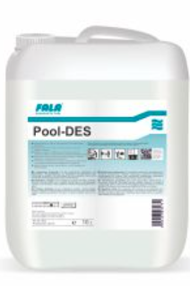  Article No. 121811 |  | FALA FONA SPEED – SANITARY CLEANER 1 L  Fona Speed is based on special organic acids and is suitable for use on all acid-resistant surfaces in sanitary facilities (tiles, ceramic surfaces, washbasins, fittings, toilet bowls, urinals...).  €5.77  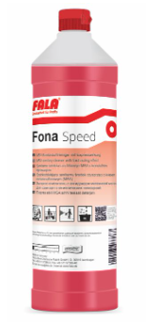  Article No. 121812 | FALA FONA SPEED – SANITARY CLEANER 10 L  It quickly and efficiently removes common impurities in sanitary facilities such as soap residues, limescale, urine tartar. Oil and grease stains will also be removed. Fona Speed protects the material from additional corrosion with its fast operation.  €43.25  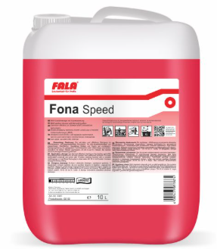  Article No. 121813
 | FALA TOILET REINGER – GEL REMEDY FOR TOILET BOWLS, PIOSOARJE 750 ML  Apply the undiluted concentrate to the cleaning surface (toilet bowl, urinal). Leave it to work for a short time. Then treat the surface with a toilet whisk and rinse.  €4.44  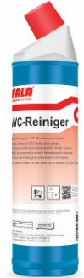  Article No. 121814 |  | FALA CERLAN LINO - BASIC LINOLEUM CLEANER AND COATING REMOVER 10 L  Suitable for use on all alkali-non-resistant soil surfaces. It also dissolves hard polymer coatings. Especially suitable for linoleum coverings. Check the colour fastness before use.  €58.58  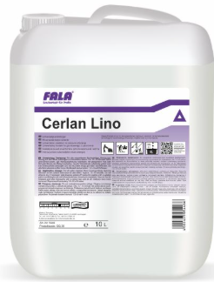  Article No. 121815 | FALLA DETACHUR UNIVERSAL – TEXTILE STAIN REMOVER 500 ML  A fundamental universal remedy for removing stains soluble in water or solvents from carpets and upholstered furniture.  €12.50  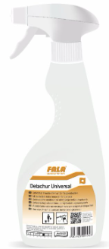  Article No. 121816

 | 6 | CLEANERS 11
 | FALPI RAPID MOP-POCKET HOLDER 40CM  FALPI mop holder RAPID 40x13 cm with pocket.  26,16  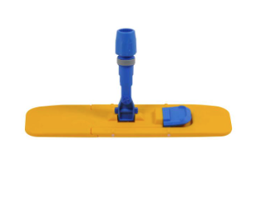  Article No. 118141 |  | FALPI MOP-POCKET HOLDER 60CM  Falpi mop holder with pocket.  5,83  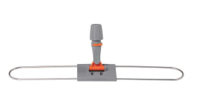  Article No. 118142 | FALPI BUCKET RED 6L  Red Bucket  7,38  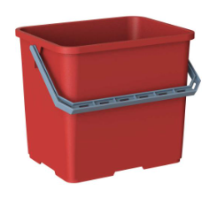  Article No. 118143
 | FALPI BUCKET BLUE 6L  Blue bucket  7,38  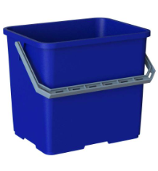  Article No. 118144 |  | FALPI BUCKET RED 10L  Red Bucket  8,05  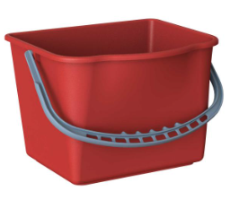  Article No. 118145 | FALPI BUCKET BLUE 10L  Blue bucket  9,52  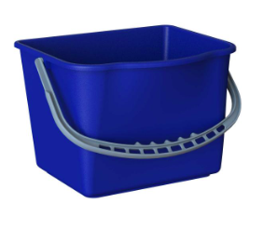  Article No. 118146

 | 7 | CLEANERS 9
 | THEDRA STAR CLEANER BETULA – UNIVERSAL CLEANER WITH FRAGRANCE 10 L  Friendly to materials with low content of surfactants and VOCs. It foams weakly, dries quickly and does not leave streaked marks. It has a fresh smell that lasts a long time.  €42.19  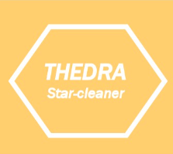  Article No. 91811 |  | THEDRA STAR CLEANER BETULA – UNIVERSAL CLEANER WITH FRAGRANCE 1 L  Friendly to materials with low content of surfactants and VOCs. It foams weakly, dries quickly and does not leave streaked marks. It has a fresh smell that lasts a long time.  €5.75  Article No. 91812 | THEDRA STAR CLEANER DUFTY – UNIVERSAL CLEANER WITH FRAGRANCE 10 L  Friendly to materials with low content of surfactants and VOCs. It foams weakly, dries quickly and does not leave streaked marks. It has a fresh smell that lasts a long time.  €41.43  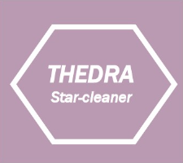  Article No. 91813
 | THEDRA STAR CLEANER DUFTY – UNIVERSAL CLEANER WITH FRAGRANCE 1 L  Friendly to materials with low content of surfactants and VOCs. It foams weakly, dries quickly and does not leave streaked marks. It has a fresh smell that lasts a long time.  €5.75  Article No. 91814 |  | THEDRA STAR CLEANER GREEN APPLE – UNIVERSAL CLEANER WITH FRAGRANCE 10 L  Friendly to materials with low content of surfactants and VOCs. It foams weakly, dries quickly and does not leave streaked marks. It has a fresh smell that lasts a long time.  €33.96  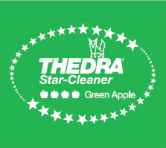  Article No. 91815 | THEDRA STAR CLEANER GREEN APPLE – UNIVERSAL CLEANER WITH FRAGRANCE 1 L  Friendly to materials with low content of surfactants and VOCs. It foams weakly, dries quickly and does not leave streaked marks. It has a fresh smell that lasts a long time.  €7.22  Article No. 91816

 | 8 | CLEANERS 11
 | PLATINUM REED DIFFUSERS OUD WOOD 100ML  Immerse yourself in the world of luxury home fragrances and discover the magic of Platinum Line Reed diffusers.  €27.19  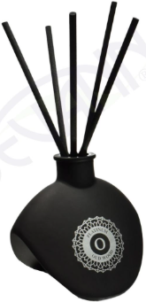  Article No. 88151 |  | PLATNIUM REED DIFUSERS WHISPERS 100ML  Immerse yourself in the world of luxury home fragrances and discover the magic of Platinum Line Reed diffusers.  €26.70  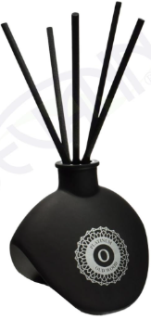  Article No. 88152 | DR. SCHNELL DUFTSPRAY EXOTIC - ROOM FRESHENER EXOTIC 500ml  Scope  To prevent annoying odors in the shortest possible time.  €5.30  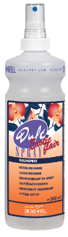  Article No. 88153
 | THEDRA DUFT GRANULATE LUKARO- FRAGRANT GRANULES FOR VACUUM CLEANER 200ml  Instructions for use: Place one teaspoon of granules on the ground and vacuum.  €8.00  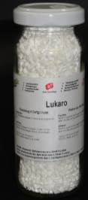  Article No. 88154 |  | HANGER FOR SANITARY FACILITIES - APPLE  Freshens the air in the toilet room for up to 60 days. A unique durable material that contains 30 times more fragrance than ordinary room fresheners.  €3.16  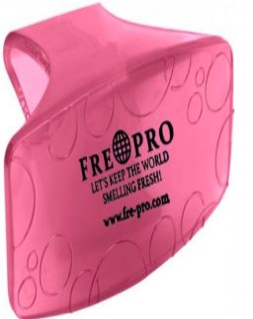  Article No. 88155 | HANGER FOR SANITARY FACILITIES - MANGO  Freshens the air in the toilet room for up to 60 days. A unique durable material that contains 30 times more fragrance than ordinary room fresheners.  €4.36  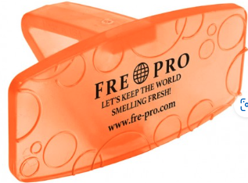  Article No. 88156

 | 9 | CLEANERS 13
 | FALA HAAR EX – ROHRTEUFEL – EFFLUENT DEGREASER 1 L  Concentrated liquid drain cleaner. It quickly and effectively removes hair, soap residue, grease and other dirty ingredients from siphons and drains.  €11.52  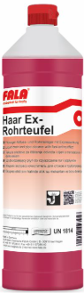  Article No. 131811 |  | FALA FROWL – CLEANER AND PROTECTION FOR STAINLESS STEEL 300 ML  Frowi cleaner and protection in one is suitable for all stainless steel surfaces such as work surfaces (countertops), bars, shelves, elevators and wall coverings. It leaves a very thin nourishing layer on the surface.  €19.23  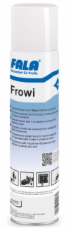  Article No. 131812 | FALA LAMITOP – CARE AGENT FOR LAMINATE, PARQUET, COUNTERTOP 1 L  For basic daily cleaning of the laminate. Also suitable for cleaning laminate floors with closed joints, cork and other plastic surfaces. It removes daily impurities such as grease and areas with deposits or plaques.  €6.04  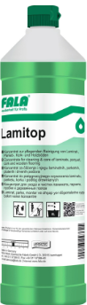  Article No. 131813
 | FALA RAUMDUFT MELONE – MELON ROOM FRESHENER 1 L  Apply the undiluted product to an inconspicuous area (e.g. sink overflow, toilet sink, toilet brush bowl, drain, etc.). The smell spreads throughout the room. Only a few syringes are required for extensive operation  €15.25  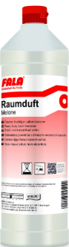  Article No. 131814 |  | FALA CERLAN – BASIC CLEANER FOR REMOVING STUBBORN DIRT 10 L  Removes all kinds of stubborn stains, from plastic to wax. For larger coatings and reusable, but with an intermediate reaction time, without renewal of the detergent solution, but the soil should not dry out.  €55.77  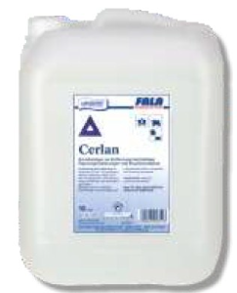  Article No. 131815 | P-LINE ALCOHOLREINIGER – ALCOHOL CLEANER 1 L  The alcohol cleaner is suitable for daily maintenance cleaning of all water-resistant surfaces. It is a versatile cleaner, especially suitable for cleaning floor surfaces (PVC, laminate, tiles, linoleum), glass, ceramic tiles, plastics and varnished surfaces. Does not leave spots on the surface of the cleaning.  €3.65  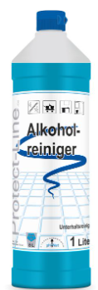  Article No. 131816

