CATALOGUE 2025/26

UP ZOJO, D.O.O.


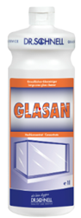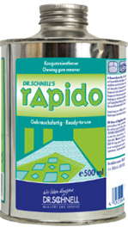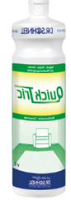

 | 2 | GENERAL INFORMATION
  ISSUER:  UP Zojo, d. o. o.  Production, services and trade  Secondary School of Economics, Services and Civil Engineering, SC Kranj, Cesta Staneta Žagarja 33, 4000 Kranj  Tel: 00386 059 093 900  Fax: 00386 059 093 901  E-mail: upzojo7@gmail.com  https://zojoeng.splet.arnes.si  RELEASE DATE:  september 2025 | AUTHORS OF THE CATALOGUE:  ● TARA KRCMAR, director of the company  (cleaners 4)  ● MUBINA MIZIC, Marketing Director  (cleaners 3)  ● LARA PAJIC, Purchasing and Sales Officer 1 (cleaners 6)  ● SASA PRACA, Purchasing and Sales Officer 2 (cleaners 2)  ● LANA SVOBODA, Purchasing and Sales Officer 3 (cleaners 5)  ● DAJANA TRIVUNČEVIC, Purchasing and Sales Officer (cleaners 8) | TERMS OF SALE:  The offer is valid until stocks last.  The images are symbolic.  SPONSORED BY THE LEARNING COMPANY:  
 | 3 | INDEX
CATALOGUE INDEX:

GENERAL INFORMATION 2
INDEX 3
CLEANERS 4 4
CLEANERS 3 5
CLEANERS 6 6
CLEANERS 2 7
CLEANERS 5 8
CLEANERS 8 9

 | 4 | CLEANERS 4
 | DR. SCHNELL GLASAN - GENERAL GLASS CLEANER, C. FRAMES, BLINDS 1 l  Features: Easily removes oily, greasy and sooty dirt, dust from the atmosphere. It dries without streaks and residues. Effective cleaning even at low temperatures.  €6.30  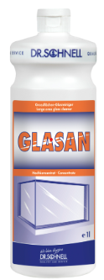  Article No. 41811 |  | DR. SCHNELL GLASAN - GENERAL GLASS CLEANER, C. FRAMES, BLINDS 5 L  Features: Frost-free. Softens and dissolves chewing gum residues  €39.46  Article No. 41812 | DR. SCHNELL QUICK TRIC - EXTRACTION CLEANER FOR UPHOLSTERED FURNITURE 1 L  Use: To remove stains, use diluted with water in a ratio of 1:1. For spray cleaning, diluted with water in a ratio of 1:4 to 1:10 is used. For mechanical or manual cleaning of water-resistant surfaces, use a 20% solution.  €14.22  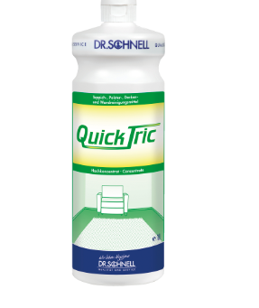  Article No. 41813
 | DR. SCHNELL FLOORFIT - NOURISHING PARQUET CLEANER AND COATING 1 L  Scope of application: For all waterproof floor surfaces such as linoleum, PVC, rubber, natural and artificial stone, brick and cotto. Leaves a shiny non-slip protective layer. Also suitable for the care of varnished parquet. Not suitable for wet areas and water-sensitive surfaces.  €9.11  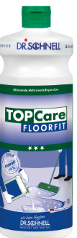  Article No. 41814 |  | DR. SCHNELL FLOORFIT - NOURISHING PARQUET CLEANER AND COATING 10 L  Scope of application: For all waterproof floor surfaces such as linoleum, PVC, rubber, natural and artificial stone, brick and cotto. Leaves a shiny non-slip protective layer. Also suitable for the care of varnished parquet.  €54.42  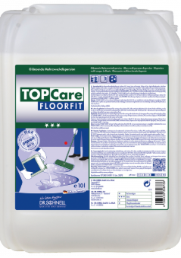  Article No. 41815 | DR. SCHNELL RAPIDO - CHEWING GUM REMOVER 500 ML  Features: Frost-free. Softens and dissolves chewing gum residues.  €11.86  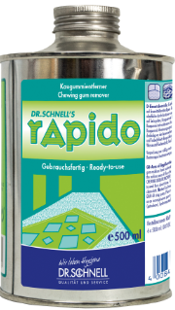  Article No. 41816

 | 5 | CLEANERS 3
 | DR. SCHNELL FOROL ECO - ECOLOGICAL UNIVERSAL CLEANER 1 L  Scope: Suitable for cleaning all waterproof flooring and surfaces such as plastic, glass, etc.  €4.82  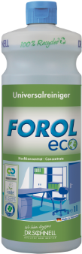  Article No. 31811 |  | DR. SCHNELL GASTRO PUR ECO - ORGANIC OIL AND FAT REMOVER 1 L  Scope of application: GASTRO PUR ECO can be used in all food processing plants, for example in commercial kitchens, bakeries and butcher shops.  €8.61  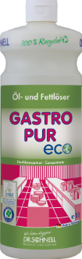  Article No. 31812 | DR. SCHNELL GASTROFEE - OIL AND FAT REMOVER 500 ML  Features: Ready-to-use spray degreaser.  €4.92  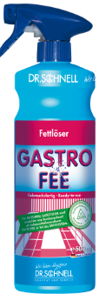  Article No. 31813
 | DR. SCHNELL MILOSTAR - CLEANSING, NOURISHING AND POLISHING AGENT 500 ML  Scope of application: Suitable for glass, ceramic hob and all water-resistant, shiny surfaces.  €6.81  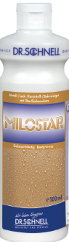  Article No. 132001 |  | DR. SCHNELL PEN ANTIKALK - DESCALER FOR SMALL HOUSEHOLD APPLIANCES 1 L  Scope of application: Descaler for small household appliances such as water heaters and coffee machines.  €6.98  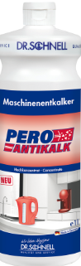  Article No. 132001 | DR. SCHNELL MAFOR S - GLOSS DISHWASHER LIQUID 1 L  Scope of application: Suitable for dishwashers, convection ovens/combi in areas with medium hard and hard water.  €10.91  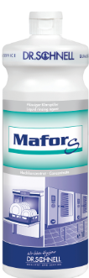  Article No. 132001

 | 6 | CLEANERS 6
 | UNGER ORIGINAL STRIP GLASS IRRIGATOR 35 CM  Utility for cleaning windows.  €12.65  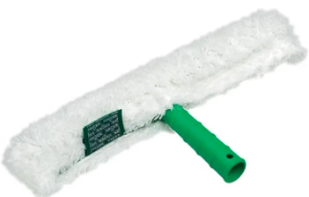  Article No. 61811 |  | UNGER ORIGINAL STRIP SOAKING FOR GLASS 45 CM  Utility for cleaning windows.  €18.12  Article No. 61812 | UNGER ORIGINAL STRIP GLASS IRRIGATOR 25 CM  Utility for cleaning windows.  €14.04  Article No. 61813
 | UNGER ORIGINAL STRIP SOAKED FOR GLASS 25 CM  Utility for cleaning windows  €19.54  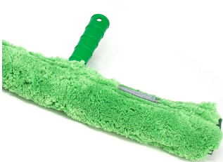  Article No. 61814 |  | UNGER MICROSTRIP GLASS IRRIGATOR 45 CM  Utility for cleaning windows.  €22.65  Article no. 61815 | UNGER MICROSTRIP GLASS IRRIGATOR 45 CM  Utility for cleaning windows.  €15.50  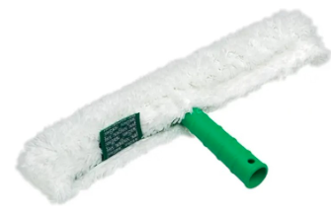  Article No. 61816

 | 7 | CLEANERS 2
 | DR. SCHNELL UNIMAGIC – universal cleaner with micro technology 10 l  Scope of application: Suitable for all waterproof floor and other surfaces (matte or glossy). Antistatic.  5.87 HOURS  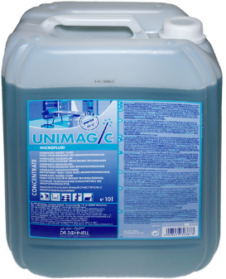  Article No. 21811 |  | DR. SCHNELL LAVIDOL – marble cleaner 10 l  Scope:  For all waterproof surfaces, high-quality fittings, designer bathtubs, ceramic tiles, enameled surfaces, marble.  110,36EUR  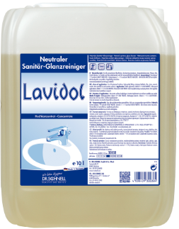  Article No. 21812 | DR. SCHNELL LEMONFRESH – sanitary cleaner with bactericidal action 1l  Scope of application: All acid-resistant surfaces. Even for professional use.  €5.50  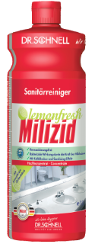  Article No. 21813
 | DR. SCHNELL MILIZID SHINE – sanitary cleaner with drip effect 1 l  Scope of application: Intensive 3-phase sanitary cleaner for hygienic cleanliness of all acid-resistant surfaces in sanitary areas.  7,28EUR  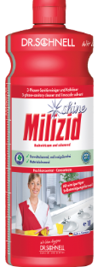  Article No. 21814 |  | DR. SCHNELL MILIFIX – sanitary cleaner after construction work 1l  Scope of application: For the removal of intense stains and dirt such as limescale, urine scale and rust in sanitary facilities.  6,37EUR  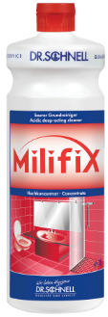  Article no. 21815 | DR. SCHNEL GRUN & MILD ECO – ecological dishwashing detergent 1 l  Scope of application: For manual cleaning of dishes, cutlery, glasses.  5,87EUR  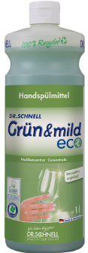  Article No. 21816

 | 8 | CLEANERS 5
 | THERDA DUFT GRANULATE LUKARO-SCENTED GRANULES FOR VACUUM CLEANER 200ML  Instructions for use: Place one teaspoon of granules on the ground and vacuum.  8,15EUR  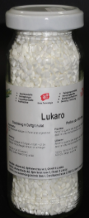  Article No. 51811 |  | THERDA TAPIMEX-EXTRACTION CLEANER FOR UPHOLSTERED FURNITURE 1L  Features: Extracted carpet cleaner for cleaning upholstered furniture and carpets. It dissolves dirt and grease without any problems. It inhibits the reception of new dirt.  5,72EUR  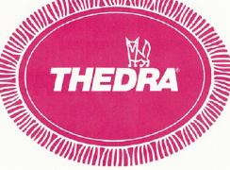  Article No. 51812 | PRAMOL CRISTALLO-CRYSTALLIZATION POWDER WITH HIGH GLOSS 5KG  High gloss crystallization powder for polishing/crystallizing marble and stone cladding containing limestone.  72,55EUR  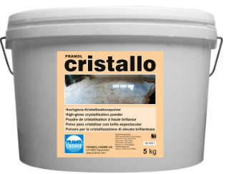  Article No. 51813
 | THERDA CALCEX ENTKALKER-DESCALER 10L  Characteristics: Based on phosphoric acid, it reliably removes limestone residues in kitchens, sanitary facilities, toilets, fittings, as well as on acid-resistant machines and devices that are subject to the formation of limestone coatings.  33,09EUR  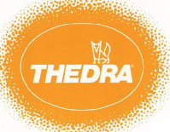  Article no. 51814 |  | THERDA CALCEX ENTKALER-DESCALER 10L  Characteristics: Special cleaner for particularly stubborn limestone crusts and linings intended only for urinals and toilet bowls.  5,15EUR  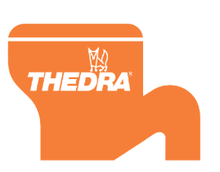  Article No. 51815 | THERDA CLOSETT BEIZE-DESCALER FOR TOILET BOWLS  Characteristics: Special cleaner for particularly stubborn limestone crusts and linings intended only for urinals and toilet bowls.  30,64EUR  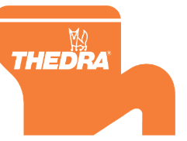  Article No. 51816

 | 9 | CLEANERS 8
 | THEDRA LINOFIX – LINOLEUM PAINT REMOVER 1 L  It melts wax and plastic coatings especially on linoleum, melts dirt of all kinds, foams weakly, without hazard markings.  4,93  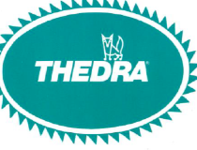  Article No. 81811 |  | THEDRA LINOFIX – LINOLEUM PAINT REMOVER 10 L  It melts wax and plastic coatings especially on linoleum, melts dirt of all kinds, foams weakly, without hazard markings.  43,16  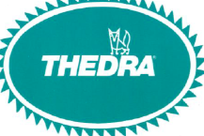  Article No. 81812 | THEDRA ACRYL-SELBSTGLANZDISPERSION ST – HIGH GLOSS COATING FOR PLASTICS 1 L  serves as a coating for all smooth plastics, PVC, linoleum, rubber and asphalt floors. It creates a solid surface with a high gloss. It protects the floor covering from premature wear and facilitates wet wiping. It is alcohol-resistant.  9,37    Article No. 81813
 | THEDRA ACRYL-SELBSTGLANZDISPERSION ST – HIGH GLOSS COATING FOR PLASTICS 10 L  serves as a coating for all smooth plastics, PVC, linoleum, rubber and asphalt floors. It creates a solid surface with a high gloss. It protects the floor covering from premature wear and facilitates wet wiping. It is alcohol-resistant.  91,08    Article No. 81814 |  | THEDRA PARKETTGLANZ – PARQUET COATING 1 L  THEDRA Parkettglanz is a polymer dispersion containing waxes. It achieves a protective film on unprotected and also varnished wooden floors. It protects the new parquet and gives the old one a silky sheen. Simplifies daily cleaning.  8,64  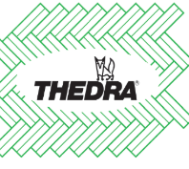  Article No. 81815 | THEDRA PARKETTGLANZ – PARQUET COATING 10 L  THEDRA Parkettglanz is a polymer dispersion containing waxes. It achieves a protective film on unprotected and also varnished wooden floors. It protects the new parquet and gives the old one a silky sheen. Simplifies daily cleaning.  60,36  Article No. 81816

