CATALOGUE 2025/26

UP DONA, D.O.O.



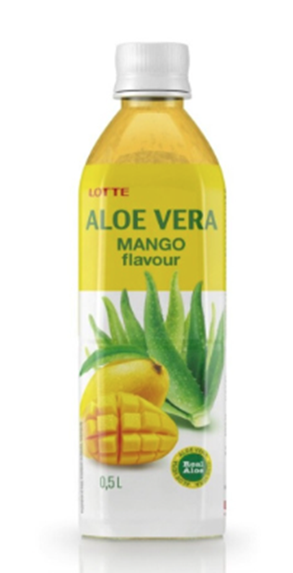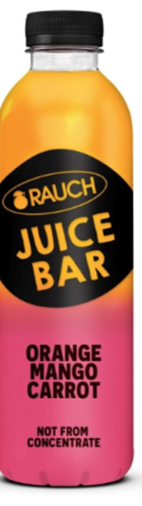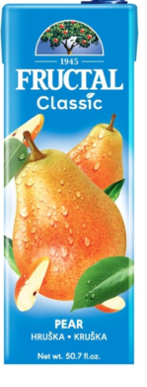

 | 2 | GENERAL INFORMATION
  ISSUER:  UP Dona, d. o. o.  Production, services and trade  Secondary School of Economics, Services and Civil Engineering, SC Kranj, Cesta Staneta Žagarja 33, 4000 Kranj  Tel: 00386 059 093 900  Fax: 00386 059 093 901  E-mail: updona7@gmail.com  https://donaeng.splet.. arnes.si  RELEASE DATE:  october 2025 | AUTHORS OF THE CATALOGUE:  ● Eva Cadez, company director (Fructal beverages 4)  ● Zan Begovic, Marketing Director (Fructal Beverages 8)  ●Mojca Mrak, Purchasing and Sales Officer 1 (Fructal beverages 1)  ●Eva Kepec, Purchasing and Sales Officer 2 (Fructal beverages 5)  ●Erazem Ficko, Purchasing and Sales Officer 4 (Fructal Beverages 10) | TERMS OF SALE:  The offer is valid until stocks last.  The images are symbolic.  SPONSORED BY THE LEARNING COMPANY:  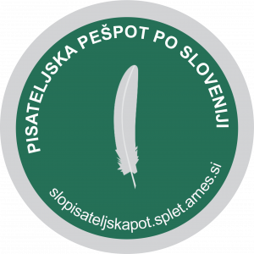
 | 3 | INDEX
CATALOGUE INDEX:

GENERAL INFORMATION 2
INDEX 3
FRUCTAL DRINKS 4 4
FRUCTAL DRINKS 8 5
FRUCTAL DRINKS 1 6
FRUCTAL DRINKS 5 7

 | 4 | FRUCTAL DRINKS 4
 | DRINK, ALOE VERA WITH MANGO  Ingredients: Water, Cane Sugar, Aloe Vera Gel, Mango Flavor, Aloe Vera Powder, Calcium Lactate, Citric Acid, Vitamin C, Gellan Gum, Sodium Citrate, Natural Dye  €1.45  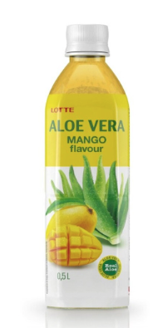  Article No. 48221 |  | JUICE, ORANGE, MANGO AND CARROT, RAUCH JUICE BAR, 0.8 L  Ingredients: Orange juice 90%, mango pulp 7%, carrot puree 3%, vitamin C.  €3.14  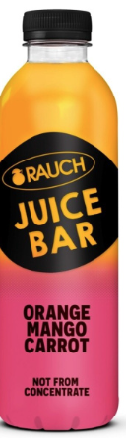  Article No. 48212 | DRINK, PEAR, FRUCTAL, 1.5 l  Ingredients: Water, pear puree, acid (citric acid), antioxidant (ascorbic acid), sweetener (sucralose) and flavoring.  €2.15  Article No. 48213
 | DOUBLE C DRINK, FRUCTAL, 1 L  Ingredients: Water, Concentrated Orange Juice, Sugar, Glucose-Fructose Syrup, Acid (Citric Acid), Flavorings, Antioxidant (Ascorbic Acid) and Colorants (Beta Carotene, Beta-Apo-8-Carotene)  €2.47  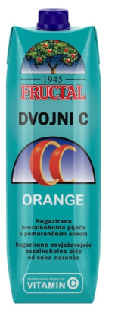  Article No. 48214 |  | JUICE, MULTIVITAMIN FRUCTAL, 1  l  Ingredients: In variable proportions, fruit juices from concentrated juices: apples, grapes, lemons, elderberries, black currants, chokeberry, cherries and raspberries, vitamins (C, niacin, pantothenic acid, B6, biotin, B12).  €3.01  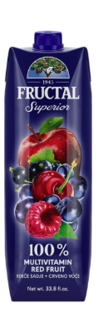  Article No. 48215 | JUICE, MULTIVITAMIN RED, HOHES C, 1 l  Ingredients: Juice of grapes, apples, and raspberries  €4.32  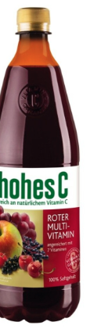  Article No. 48216

 | 5 | FRUCTAL DRINKS 8
 | DRINK, STRAWBERRY, APPLE AND CHOKEBERRY, FRUCTAL, 1.5 L  Ingredients: Water, strawberry pulp, apple pulp, sugar, chokeberry juice from concentrated juice, glucose-fructose syrup, acid (citric acid), coloring (black carrot juice) and flavoring.  €2.66  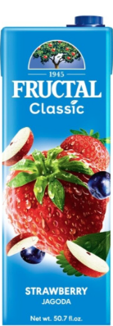  Article No. 88211 |  | NECTAR, SLOVENIAN FRUIT, FRUCTAL, 1 L  Ingredients: water, apple juice 29%, pear puree 20%, sugar, glucose-fructose syrup, peach pulp 1%, acid (citric acid), antioxidant (ascorbic acid).  €2.55  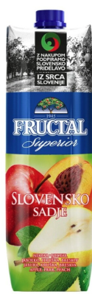  Article No. 88212 | DRINK, LEMONADE, FRUC, 1.5 L  Ingredients: Water, sugar, lemon juice from concentrated juice 4.5%, orange juice from concentrated juice 2.5%, acid (citric acid), concentrated lemon extract...  €1.66  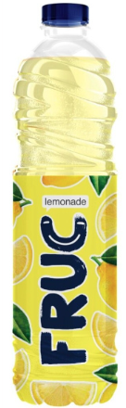  Article No. 88213
 | SYRUP, ORANGE, FRUCTAL, 1 L  Ingredients: Glucose-fructose syrup, sugar, water, orange juice from concentrated juice, acid (citric acid), flavoring...  €5.29  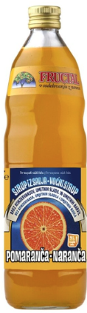  Article No. 88214 |  | LIQUEUR, BLUEBERRY, FRUCTAL, 1 L  Ingredients: made from fruit distillate, concentrated blueberry juice, enriched with blueberry fruits  €11.29  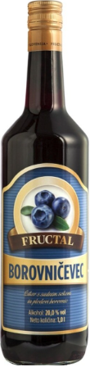  Article No. 88215 | DRINK, CARROT, ORANGE AND LEMON, FRUC, 0.5 L  Ingredients: water, carrot juice and orange juice from concentrated juices, sugar, lemon juice from concentrated juice, glucose-fructose syrup, acid...  €0.84  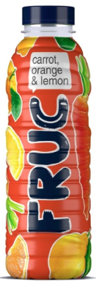  Article No. 88216

 | 6 | FRUCTAL PIJAČE1
 | NECTAR, STRAWBERRY, FRUCTAL, 0.2 L  water, strawberry puree (30%), apple puree (11%), sugar, glucose-fructose syrup, grape juice from concentrated juice (4%) and acid (citric acid )  €0.87  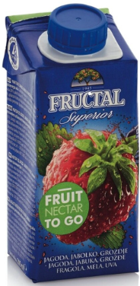  Article No. 38211 |  | JUICE, ORANGE, FRUCTAL, 0.2 L  Produced from concentrated orange juice  €0.39  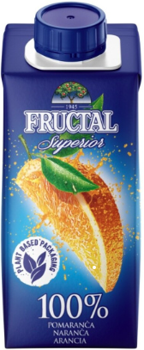  Article No. 38212 | DRINK, PINGO, 0.2 L  Water, orange juice from concentrated juice, sugar, lemon juice from concentrated juice, glucose-fructose syrup, acid (citric acid), flavourings, antioxidant (ascorbic acid) and colours (beta carotene, beta-apo-8'-carotene)  €0.39  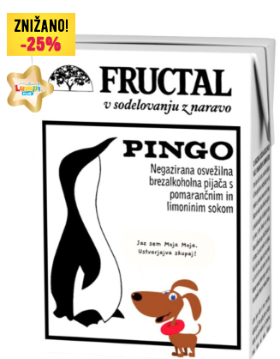  No. Article 38213
 | NECTAR, BLACKCURRANT, FRUCTAL, 0.2 L  Water, blackcurrant juice from concentrated juice, sugar and glucose-fructose syrup  €0.71  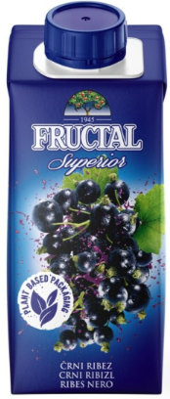  Article No. 38214 |  | DRINK PINGO, FRUCTAL, 1.5 L  Water, orange juice from concentrated juice (7%), sugar, lemon juice from concentrated juice (3%), glucose-fructose syrup, acid (citric acid), flavourings, antioxidant (ascorbic acid) and colours (beta carotene, beta-apo-8'-carotene  €1.60  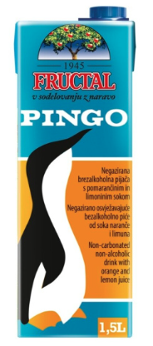  Article No. 38215 | STILL WATER FIRST, LIME AND MINT, FRUCTAL, 0.5 L  Water, sugar, lime juice from concentrated juice (0.3%), acid (citric acid), natural lime flavouring, L-carnitine (0.05%), zinc gluconate, mint extract (0.04%), vitamin B6  €2.48  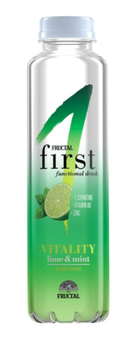  Article No. 38216

 | 7 | FRUCTAL DRINKS 5
 | TOMATO PUREE, FRUCTAL, 500 ML  Ingredients: Tomato puree from concentrated tomato puree (99.7%), table salt  €0.81  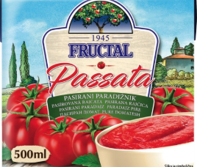  Article No. 58211 |  | SYRUP, MULTIVITAMIN, MERCATOR, 1 L  Ingredients: Sugar, water, apple juice from concentrated fruit juice of apples (9%), juice from several types of fruits and vegetables concentrated juice in variable proportion (1%) (oranges, lemon, carrots, pineapple, passion fruit, mango), vitamins (vitamin C, vitamin E,  €3.22  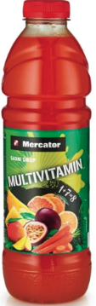  Article No. 58212 | ICED TEA, VIPAVA VALLEY PEACH, FRUCTAL, 1.5 L  Ingredients: Water, sugar, peach pulp 5%, glucose-fructose syrup, acid (citric acid), rosehip and black tea extract 0.18%, antioxidant (ascorbic acid), rosehip and peach aroma. The drink is pasteurized, without preservatives.  €1.60  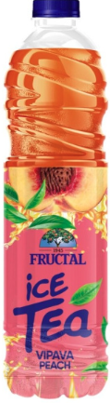  Article No. 58213
 | STILL WATER FIRST, LEMONGRASS, FRUCTAL, 0.5 L  Ingredients: Water, sugar, acid (citric acid), lemon juice from concentrated juice (0.1%), lemongrass extract (0.05%), natural flavouring, vitamins (pantothenic acid, B6, B12).  €1.17  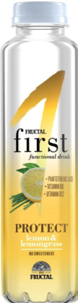  Article No. 58214 |  | DRINK, BLUEBERRY, FUCTAL, 1 L  Ingredients: water, red grape juice (22%) from concentrated juice, sugar, blueberry juice (3%) from concentrated juice, glucose-fructose syrup, acid (citric acid), blueberry aroma.  €0.96  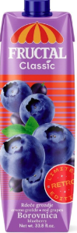  Article No. 58215 | NECTAR, MULTIVITAMIN, HAPPY DAY, 1 L  Ingredients: Water, 25% juice of several fruits from concentrated juices (apple, elderberry, black currant, grapes, cherry, lemon, raspberry, cranberry, blackberry, blueberry, pomegranate), sugar,  €3.09  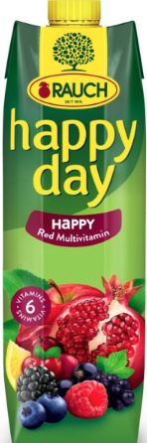  Article No. 132001

