CalDigit TS4 Thunderbolt 4 Docking Station

Product name: CalDigit TS4 Thunderbolt 4 Docking Station (18-Port Dock)
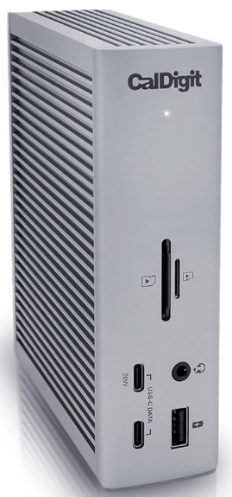
Product description: Professional Thunderbolt 4 dock with 18 ports, 98 W charging, support for 8K/6K displays, 2.5 GbE networking, and broad compatibility with Mac, Windows, and USB-C devices.
Price: 470,14 (incl. 22% VAT)
Product code: 52101
Click the logo below for more information!


