Thunderbolt Docking Stations

Product name:
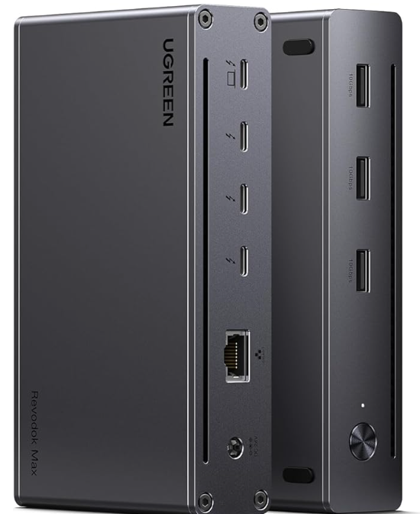
Product description:

Price: (incl. 22% VAT)
Product code:
Click the logo below for more information!


